Sparkle to Success
Finding the Light Within
Susan Kennard
BA Hons Psychology, PG Dip Psy Obs, EFT, Naturopath,
Meta Health, Theta DNA, Rahanni Trainer Angelic 5d, Mindfulness.

Sparkle to Success

Contents:

Meditation Earth Star, Soul Star©
Colour Energy Clearing©
Emotional Wall Technique ©
Time Travelling with your Inner Child and
Healing Hearts©
Projector Process©
Cutting Cords and Forgiveness Process©
Higher Self Mirror process©

Dear Soul,
I welcome you to the next part of your healing journey.
I am so glad that you chose to go on this journey of discovery. I know that you are going to heal and grow as you work through these processes. This course can be used with or without the audios, however they hold a vibrational essence from my guides to assist you as you open to healing.
My team and I were guided to share these processes so that you are able to heal yourself. These processes allow you to release unwanted childhood trauma, limiting beliefs, old energies holding you back inclusive of past lives that you have brought in with you to heal in this time. By doing this you are shifting to new timelines, your mission will become much easier for you to accomplish when you are sparkling brightly.
I have created a statement to clear your energy on a daily basis and before you decide to clear. The Earth Star- Soul Star meditation to feel grounded and connected is the one you do before you do any other processes.
Enjoy each process and connect with me at www.susankennard.co.uk
In deep gratitude with much love
Susan

Clearing Statement
Creator all that is, it is commanded that you pull, clear, cancel and delete on all four levels and resolve on the history level across all timelines, lifetimes, past present future any waywards, watchers, entities, anything that does not serve me now. Send to unconditional love, thank you, thank you, thank you, it is done.
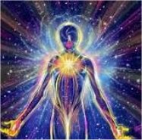

Meditation Earth Star, Soul Star©

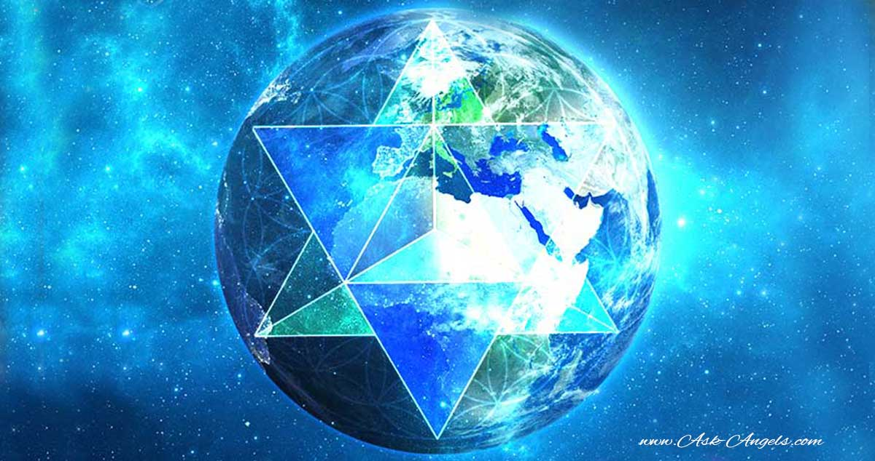

It is important to be connected to the Earth plane as well as the Universal and Multidimensional planes of existence. My guides gave me this process many years ago to allow us to feel connected in this human form as well as connected on a soul level. They tell me that many remember who they are, however forget that they had agreed to be connected to Gaia or mother earth. This is a great process to allow you to ground and connect. Teach it to your children too calling it Star in the ground, Star in the sky.
Putting your hands on your heart, breathing normally connect to your heart centre.
Imagine a beautiful golden cord travelling from your feet into the ground and watch it as it goes deeper to find your earth star. Even if you can’t see it, just imagine it’s there.
Then imagine the golden cord travelling up to the top of your head and shooting up to the universe where you will find your 6 pointed golden Soul Star.
Connect with the star which contains all of the knowledge from all of your lifetimes where you remembered you were pure love and bring it down to your heart.
Expand that knowing and light throughout to the whole of your energy field watching it sparkle.
Knowing you are connected to your Earth Star and Soul Star you can develop a clearer connection to your guides helping you to feel safe in this world.

Colour Energy Clearing©

When we imagine or see colour during energy processes, it shows us that we are connecting to the emotion, energy block or resistance.
When we ask what colour the client is seeing, we can access the emotion they are feeling. We can watch as it changes colour and therefore clears the emotion and the block without needing to know where it came from.
Here is a list of colours and my inspired interpretation;
Pink and gold sparkling- pure heart opening love
Platinum sparkling - pure healing vibration we can use this to transmute and align our connection to source.
Gold sparkling- Beginning of freedom and more light and energy in the field.
Magenta –higher communication.
Violet- cleansing light.
Orange- empowerment/disempowerment.
Yellow- childhood trauma.
Pink/green- heart, deep hurt, pain and rejection.
Blue- communication, not being heard, not listened to.
Dark Blue- another’s way of communication.
Turquoise-usually a need to save everyone the world.
Red- Security in the world, can be frustration and anger.
Purple- healing grief towards your true spiritual purpose
White- Fear or when mixed with another colour, fear of that particular colour.
Grey- old shock
Black- old dense energy, past life, conception to birth.

Emotional Wall Process ©

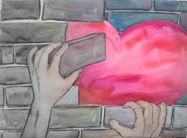

The emotional wall was born from my work with war veterans who had told their story so many times to psychologists and doctors that they were so tired. The guides gave me this process to help to clear the first time you ever felt disconnected to source/god/universe. When we experience trauma or perceptions of belief that are either not true such as words someone told us, events that lead us to be afraid of the world or in fact anything that stops us from being the absolute best version of ourselves, then we have an emotional wall that is put up in our heart. This did serve a purpose at the time, however when we see that we are not able to manifest or attract what we need or desire, then we know we have walls. They stay there, show us just how much self-love we have and how connected we are to our mission. Below is the process that will heal the child and disappear that wall.

- Think of the issue you are having at the moment, or just imagine fear as a wall, then follow the steps below.
- How high is your wall, is it above your head or below?
- What’s over your wall or imagine what you could see?
- Imagine a child standing next to you. This is your inner child who needs healing who has been outside of you all your life feeling fear.
- How old is the child standing next to you?
- How does that child feel that the wall is in front of them?
- Put yourself in a golden ball of light and your child in a ball of light. Check which emotion they are holding by the colour chart in this course.
- Imagine 3 angels behind the child each one giving the child a star of; unconditional love, connection and empowerment, freedom and happiness. You can also listen to many other emotions that they may need, these are just the main ones. Another option is for the child to choose each one, look at the colour once again and connect with the emotion.
- How does your child feel now?
- Get one angel to hand your child a magic wand, if the wall is still there in parts, get them to whizz it away.
- What’s in front of you now?
- Turn to your child and say, ‘I will always love and accept you for whoever you choose to be, whatever you choose to be and whoever you choose to be with. I am going to pop you in my heart where you will always feel safe and we are going to have so much fun together creating.
- You can also add with compassion if the child is still stuck and not ready to integrate; I am so sorry you felt ………………
- Tapping on the collar-bone, repeating these words and walking forward into the scene; as I walk forward, I let go of the past and move into the present which creates my future.
- Imagine the scene. You are standing in the picture, arms wide embracing the new. Turn up the colours, sounds, maybe animals, butterflies, birds, sea, and trees are just a few. Whatever you experience is perfect. Imagine that in your heart, breathe it in. Send the intention to the universe of the new imprinted version of you.

Time Travelling with your Inner Child and Healing Hearts©

Sometimes we actually have a specific memory that keeps coming up in our life. It could be an ending of a relationships or a house move, childhood experience or in fact anything that arises. This is because it is held as a cellular imprint of memory and your incredible body is showing you that has not been healed.
Using a similar process with angels as in the emotional wall process you can help that younger version of yourself heal. You can be a child or adult, whatever age they are, they will be a younger version than today.
- Place your child/adult in a bubble of protective light.
- Imagine standing next to them.
- Connect with the emotion of the child/adult self. They may be in shock or fear. You will be able to see it and feel it.
- Bring the angels in as you did with the wall process healing using the stars. This allows that part of you to heal and feel connected to your inner guidance or if you would like to your universal team that looks after you.

- Ask your child/adult self what they need from you and then tell them I am so sorry you felt so ………….and there was no one there to hold you and keep you safe.
- Keep doing this until they are ready to integrate into your heart.
- Sometimes it’s important for your younger self to say how they felt to another person involved. If this is the case, go to the Cutting cords process and follow the process to forgive.
Projector Process©

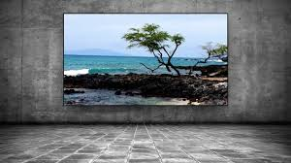

This process is fabulous for actually talking energy out of you and clearly seeing it on a screen. Think about something that stops you once again and this process will help you to release the blocks held in your field. This can be particularly helpful when we can’t access our emotions but can imagine a colour.
Imagine a white screen in front of you or to your side
- Project the colour onto the screen that is inside you. Use the Colour Energy Clearing chart to help you.
- If the colour could speak, what would it say?
- Imagine that there is an archway of light within that colour and observe your little inner child.
- How old is the child standing in the archway or colour?
- Really connect with what it is in front of you on the screen.
- Using the angels with the other processes to heal the aspect of you that is showing itself and integrate within your heart.

Cutting the Ties that bind with forgiveness©

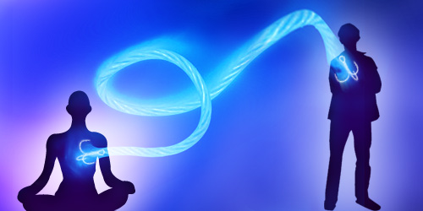

This process has shown to clear old contracts, past lives, instantly heal marriages, help divorce or heal without needing divorce, healed mother/father relationships, bosses, work colleagues and even abusers.
Why is that you ask?
We are all connected and the relationships that show up outside of us that bother us are actually a mirror of our own lack of self-love, anger resentment, fear, loss, in fact whatever emotion shows up. When we heal these, our vibration has more light therefore we show more love out to the world and the world shows it back. Simple.
- Imagine a person here or in spirit who you would like to heal your relationship with. Remember this is just to cut the ties that bind, that don’t serve you, not the loving ones or marriages in this life. Unless of course they no longer are for your highest and best good.
- Ground yourself using Earth Star/Soul Star then invite the person to join you and imagine them in your mind.
- As you look at them and they look at you, how does it make you feel? What emotions come up for you?
- It’s not your job to heal them so we will do that for you. Imagine them receiving pure connection to source, unconditional love and whatever else you feel they need. If you prefer, just hand it over and know that they will receive exactly what they need to heal.
- Notice now how you feel.
- Has something changed for you?
- Next it’s time to cut the ties that have bound you, lifetime after lifetime stopping you from being free.
- Say to them ‘Today from a place of unconditional love, I choose to set myself free and as I do that I set you free.
- I choose to forgive myself as I forgive you.
- I let go of anything from any lifetime, past, present or future that does not serve us. Some aspects are as follows; pacts, agreements, vows, oaths, marriages, religious orders, blood bindings, chains, sacrifices, written and verbal contracts.
- I do this with unconditional love deep within my soul.
- You then say their name and I feel……… whatever you want to say that you haven’t been able to say. Really speak from the heart.
- Say from a place of unconditional love, I am setting you free.
- Watch them float off or you can bring them into your heart.
- If it is a current relationship, you always ask the true soul reason for why you are together, the mission you have.
- Watch what happens.

Mirror Process©

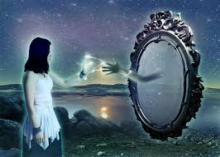

The mirror process can be used on its own or with the emotional wall process after releasing the wall.
- Imagine walking up to a full length mirror and stand in front of it.
- What do you see?
- Sometimes you will see just light. (You know with this that you have cleared to a point of utilising light) meaning the energy field is light.
- You may see yourself looking unhappy or another picture, you will see what you need to heal.
- If this is the case, step away from the mirror, invite your angels and guides to come in and fill you with light. Step in front again. What has changed?
- Sometimes you may see something in the future, for example pregnancy or family or a home or even better your mission, why you are really here.
- If it is something that you wish to hold, then see this as a picture bring the picture to your heart and feel that energy flow through your body.

Taking it further, you can ask your Higher Self to show themselves. Step away from the mirror and then fill your body from head to toe in beautiful sparkling light, then step in-front again, this is your higher-self.
Ask your higher self to talk to you and have a conversation about anything you need to know.

Susan Kennard

BA Hons Psychology, PG Dip Psy Obs, GOE EFT Master Practitioner/Trainer, Meta Health Practitioner, Theta Advanced, Rahanni Angelic Teacher. Founder Sparkle to Success and 60 seconds of colour.

www.susankennard.co.uk

